**PRELIMINARY PHYSICS**

**Syllabus Notes 2007**

**1st Edition**

**Andrew Harvey**

**PRELIMINARY PHYSICS**

**Syllabus Notes 2007**

**1st Edition**

**Andrew Harvey**

NOTE: If you make derivative works I kindly ask that you retain the text in the box, and remove my name from the footer and title pages (best to replace them with your name, but I cannot insist). (Basically I am asking you to respect two of my moral rights from the *Copyright Act 1968* (Cth) (part IX, division 2-3), the right of attribution of authorship, and the right not to have authorship of a work falsely attributed). If you want to publish derivative works where the license does not fit in with my “Share Alike” feature, email me. You will also need to remove the preamble, that or remove some of the content of the preamble that identifies me as the author.

This work is in part based on *2007 HSC Physics Syllabus Notes* by Andrew Harvey which is licensed under a [Creative Commons Attribution-Noncommercial-Share Alike 2.5 Australia License](http://creativecommons.org/licenses/by-nc-sa/2.5/au/). It can be downloaded from <http://andrew.harvey4.googlepages.com/>.

Copyright © Andrew Harvey 2007

[Creative Commons License](http://creativecommons.org/licenses/by-nc-sa/2.5/au/)  
Preliminary Physics Past Paper Solutions by Andrew Harvey is licensed under a [Creative Commons Attribution-Noncommercial-Share Alike 2.5 Australia License](http://creativecommons.org/licenses/by-nc-sa/2.5/au/).  
Based on a work at [andrew.harvey4.googlepages.com](http://andrew.harvey4.googlepages.com/).

First Edition published November 2007.

2006 Edition first released June 2006, updated July 2007. (Revised 12 December 2008)

If you have any queries on this document, I can be contacted at [andrew.harvey4@gmail.com](mailto:andrew.harvey4@gmail.com)

I would appreciate and welcome your comments/corrections/suggestions, please send them to my e-mail.

This publication contains extracts from the Board of Studies, NSW Stage 6 Physics Syllabus 1999, (Amended 2002), ISBN 1 7409 9449 3. These extracts are Copyright © Board of Studies NSW. Also the orange and blue headings, (the syllabus dot points) are Copyright © Board of Studies NSW.

Some diagrams and text in this document may have been sourced from other sources that may or may not be copyright. Any material from another source has been referenced. Any copyright for that diagram or text is vested in the owner. If you are the copyright owner of a diagram, image or extract of text used in this document and wish for it to be removed from this document, please contact me and I will willingly make the changes.

# CONTENTS

CONTENTS 4

8.2 THE WORLD COMMUNICATES 5

Contextual Outline: 5

1. The wave model can be used to explain how current technologies transfer information 6

2. Features of a wave model can be used to account for the properties of sound 9

3. Recent technological developments have allowed greater use of the electromagnetic spectrum 11

4. Many communication technologies use applications of reflection and refraction of electromagnetic waves 14

5. Electromagnetic waves have potential for future communication technologies and data storage technologies 18

8.3 ELECTRICAL ENERGY IN THE HOME 20

Contextual Outline: 20

1. Society has become increasingly dependent on electricity over the last 200 years 21

2. One of the main advantages of electricity is that is can be moved with comparative ease from one place to another through electric circuits 22

3. Series and parallel circuits serve different purposes in households 25

4. The amount of power is related to the rate at which energy is transformed 29

5. Electric currents also produce magnetic fields and these fields are used in different devices in the home 30

6. Safety devices are important in household circuits 32

8.4 MOVING ABOUT 33

Contextual Outline: 33

1. Vehicles do not typically travel at a constant speed 34

2. An analysis of the external forces on vehicles helps to understand the effects of acceleration and deceleration 36

3. Moving vehicles have kinetic energy and energy transformations are an important aspect in understanding motion 39

4. Change of momentum relates to the forces acting on the vehicle or the driver 40

5. Safety devices are utilised to reduce the effects of changing momentum 41

8.5 THE COSMIC ENGINE 42

Contextual Outline: 42

1. Our Sun is just one star in the galaxy and ours is just one galaxy in the Universe 43

2. The first minutes of the Universe released energy which changed to matter, forming stars and galaxies 45

3. Stars have a limited life span and may explode to form supernovas 46

4. The Sun is a typical star, emitting electromagnetic radiation and particles that influence the Earth 48

APPENDIX A 50

REFERENCES/ RESOURCES 52

# 8.2 THE WORLD COMMUNICATES

## Contextual Outline:

Humans are social animals and have successfully communicated through the spoken word, and then, as the use of written codes developed, through increasingly sophisticated graphic symbols. The use of a hard copy medium to transfer information in coded form meant that communication was able to cross greater distances with improved accuracy of information transfer. A messenger was required to carry the information in hard copy form and this carrier could have been a vehicle or person. There was, however, still a time limit and several days were needed to get hard copy information from one side of the world to the other.

The discovery of electricity and then the electromagnetic spectrum has led to the rapid increase in the number of communication devices throughout the twentieth century. The carrier of the information is no longer a vehicle or person — rather, an increasing range of energy waves is used to transfer the message. The delay in relaying signals around the world is determined only by the speed of the wave, and the speed and efficiency of the coding and decoding devices at the departure and arrival points of the message. The time between sending and receiving messages through telecommunications networks is measured in fractions of a second allowing almost instantaneous delivery of messages, in spoken and coded forms, around the world.

This module increases students’ understanding of the nature, practice, application and uses of physics and current issues, research and developments in physics.

© Board of Studies NSW, Stage 6 Physics Syllabus

1. The wave model can be used to explain how current technologies transfer information

1. describe the energy transformations required in one of the following:

- mobile telephone

- fax/modem

- radio and television

An energy transformation is a change in the type of energy, for example a change from sound energy to electromagnetic waves.

Relating this to the mobile telephone, it undergoes basic energy transformations of, sound wave (your voice), to electrical energy (in the wires inside the phone), to electromagnetic waves (from the phone to the tower), to electrical energy (at the tower), then to electromagnetic waves (to reach the receiving phone), then electrical energy (inside the receiving phone), then to sound waves (at the speaker of the receiving phone).

2. describe waves as a transfer of energy disturbance that may occur in one, two or three dimensions, depending on the nature of the wave and the medium

Waves are carriers of energy. Waves may be 1D, 2D, or 3D. Examples of each include; laser light, which is a one dimensional wave; water waves, which are two dimensional waves; and sound waves, which spread out in all directions from a point, so are therefore three dimensional waves.

3. identify that mechanical waves require a medium for propagation while electromagnetic waves do not

Mechanical waves, such as sound waves, water waves and earthquake waves need a medium (a substance) to travel through, they cannot move from one point to another if there is nothing (a vacuum) between the two points. On the other hand electromagnetic waves do not need a medium to travel through. An example of this is in space, which is a vacuum, if you call out in space your sound waves do not penetrate out of your space suit. However electromagnetic waves do, therefore you can see the light from the sun. Even simpler, in space you can see a planet explode, but you cannot hear it.

4. define and apply the following terms to the wave model: medium, displacement, amplitude, period, compression, rarefaction, crest, trough, transverse waves, longitudinal waves, frequency, wavelength, velocity

**Medium**: The substance through which the wave travels through.

**Displacement**: Is the distance from the rest position to the wave particle at that instant.

**Amplitude**: The distance from the rest position to the highest crest or the lowest trough.

**Period**: The time it takes for one wavelength to pass a point.   
 

**Compression**: In compression waves, the space where the particles are closest together.

**Rarefaction**: In compression waves, the space where the particles are furthest apart.

**Crest**: The parts of the wave that are above the rest position.

**Trough**: The parts of the wave which are below the rest position.

**Transverse** **waves**: Are forms of mechanical waves, they involve the particles vibrating perpendicular to the direction of the wave.

**Longitudinal** **waves**: Are also forms of mechanical waves, and they involve the particles vibrating along the direction of the wave.

**Frequency**: Frequency is the number of waves that pass a point in one second.



**Wavelength**: The distance of one full wave.

**Velocity**: The speed that the wave is propagating.



5. describe the relationship between particle motion and the direction of energy propagation in transverse and longitudinal waves

In longitudinal waves the particle motion is in the same direction as the direction of the energy propagation. On the other hand in transverse waves the particle motion is perpendicular to the direction of the energy propagation. *See blue dot point 2.*

6. quantify the relationship between velocity, frequency and wavelength for a wave: 

The velocity of a wave is equal to the frequency multiplied by the wavelength. 

$f$ is in $\text{Hz}$, $λ$ is in $\text{m}$ and is in .

1. perform a first-hand investigation to observe and gather information about the transmission of waves in:

All these examples are mechanical waves. However they represent transverse and/or longitudinal waves.

– slinky springs

Slinky springs can be used to demonstrate both longitudinal and transverse waves.

– water surfaces

Water waves represent transverse waves. By placing an object in the water, you can see that the particles move up and down.

– ropes

or use appropriate computer simulations

2. present diagrammatic information about transverse and longitudinal waves, direction of particle movement and the direction of propagation

Fig. ⑴

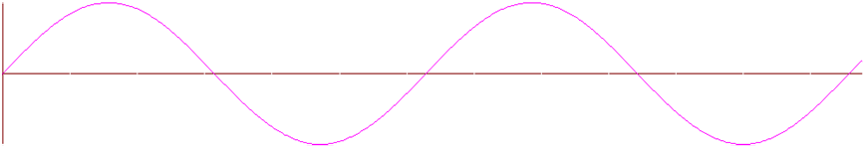

Particle Movement

Propagation

*Transverse Wave*

Fig. ⑵

**Propagation**

**Particle Movement**

*Longitudinal Wave*

3. perform a first-hand investigation to gather information about the frequency and amplitude of waves using an oscilloscope or electronic data-logging equipment

4. present and analyse information from displacement-time graphs for transverse wave motion

5. plan, choose equipment for and perform a first-hand investigation to gather information to identify the relationship between the frequency and wavelength of a sound wave travelling at a constant velocity

Given that the speed of sound in air is 343m/s and $v=fλ$. Given either frequency or wavelength you can calculate the other.

6. solve problems and analyse information by applying the mathematical model of  to a range of situations

Example Problem:

**Question:**

An FM radio station transmits a carrier wave of frequency 103.2 MHz. Calculate the wavelength of the signal.

**Solution:**



103.2 MHz = 103.2  106 Hz





## 

## 2. Features of a wave model can be used to account for the properties of sound

1. identify that sound waves are vibrations or oscillations of particles in a medium

Sound waves work by physically vibrating particles back and forth. The compression and rarefaction position moves, but the particles only vibrate, they end up back in their original position. The sound moves from one point to another from the movement of the compression and rarefaction positions.

2. relate compressions and rarefactions of sound waves to the crests and troughs of transverse waves used to represent them

The compressions and rarefactions of sound waves can be related to the crests and troughs of transverse waves respectively to represent them.

*This is only partially correct though, please see Bob Emery’s notes for a more detailed explanation.*

3. explain qualitatively that pitch is related to frequency and volume amplitude of sound waves

As frequency is related to the number of waves that pass a point in one second. The pitch is related to the number of vibrations per second. Hence the pitch of a sound is related to its frequency, the higher frequency, the higher the pitch. Similarly the volume of a sound is related to the amplitude of the wave, the higher amplitude, the louder the sound.

4. explain an echo as a reflection of a sound wave

An echo occurs when a sound wave is bounced back off a surface, thus an echo is a reflection of a sound wave.

5. describe the principle of superposition and compare the resulting waves to the original waves in sound

The superposition of a wave is the resulting wave when two or more waves occur over the top of one another. An example of this with sound waves is, if you have one person shout, and then you get two people to shout, each at the same volume as the first person, the resulting volume will be the sum of the two volumes. This can be shown graphically bellow,

Fig. ⑶

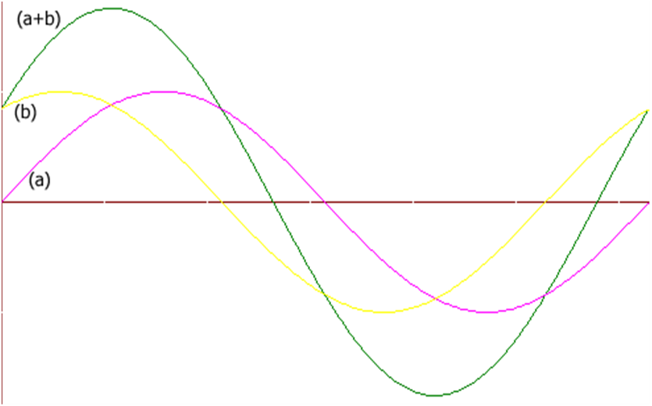

*Superposition of Waves*

When the two waves (a) and (b) are placed on top of each other a resultant wave is obtained by superimposing (adding the ordinates) the two overlapping wave.

1. perform a first-hand investigation and gather information to analyse sound waves from a variety of sources using the Cathode Ray Oscilloscope (CRO) or an alternate computer technology

2. perform a first-hand investigation, gather, process and present information using a CRO or computer to demonstrate the principle of superposition for two waves travelling in the same medium

3. present graphical information, solve problems and analyse information involving superposition of sound waves

## 

## 3. Recent technological developments have allowed greater use of the electromagnetic spectrum

1. describe electromagnetic waves in terms of their speed in space and their lack of requirement of a medium for propagation

In space (a vacuum) electromagnetic waves travel at the speed of light, a constant equal to . Unlike sound waves, electromagnetic waves do not vibrate particles, therefore they do not need a medium (substance) to propagate (move).

2. identify the electromagnetic wavebands filtered out by the atmosphere, especially UV, X-rays and gamma rays

The electromagnetic spectrum is spit up by varying wavelengths, long wavelengths are radio waves, and short ones are gamma rays. This is shown in the diagram below.

Fig. ⑷

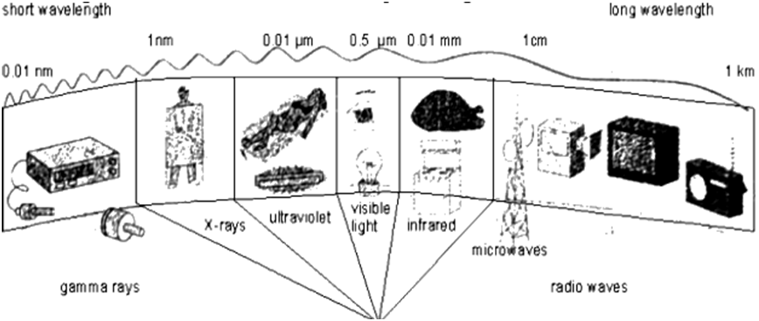

*The EMR (Electromagnetic Spectrum)*

Earth’s atmosphere filters out most of the electromagnetic waves except for visible light and radio waves. UV, X-rays and gamma rays are filtered out, these are harmful to humans.

3. identify methods for the detection of various wavebands in the electromagnetic spectrum

* Radio waves are detected with radio receivers that are connected to aerials.
* Microwaves are detected with piezoelectric crystals.
* Visible light is detected by photoelectric cells.

4. explain that the relationship between the intensity of electromagnetic radiation and distance from a source is an example of the inverse square law:  


Electromagnetic radiation attenuates over distance, i.e. the further you are away from an electromagnetic source the less the intensity will be. This can be applied to light, as if you move away from a light it will be less bright. The Intensity is proportional to the inverse of the distance square, or 

5. outline how the modulation of amplitude or frequency of visible light, microwaves and/or radio waves can be used to transmit information

Modulation of radio waves, both amplitude and frequency modulation are used today in AM/FM radio and television. The changes in the amplitude or frequency contain digital data.

AM stands for amplitude modulation, and FM stands for frequency modulation. They are both transmitted by a carrier wave. Where AM adds a wave to the carrier wave that changes the resulting wave’s amplitude. And where FM adds a wave to the carrier wave that changes the resulting wave’s frequency.

**Carrier wave:**

A carrier wave has constant Amplitude and wavelength.

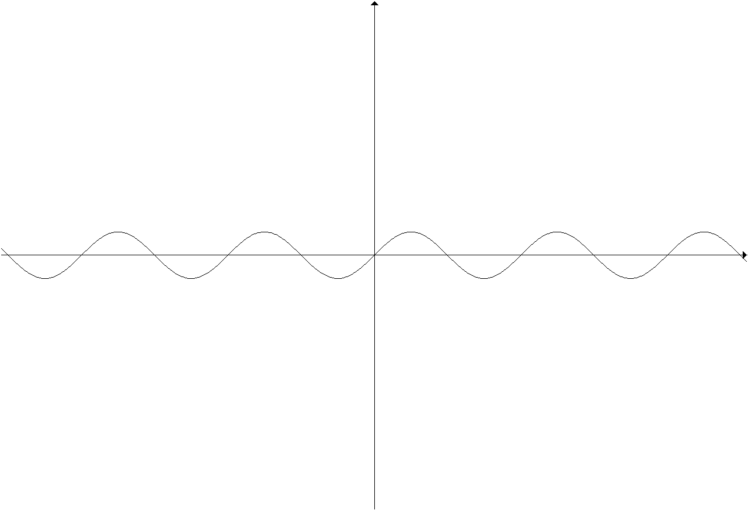

6. discuss problems produced by the limited range of the electromagnetic spectrum available for communication purposes

There is only a limited range of wavelengths in the electromagnetic spectrum that can be used for communication purposes.

1. plan, choose equipment or resources for and perform a first-hand investigation and gather information to model the inverse square law for light intensity and distance from the source

Using a light meter, and a ruler, you can obtain appropriate values relating distance and intensity. Using this data you can find the relationship of intensity and distance, for all electromagnetic waves to be,



Example Problem:

**Question:** Two kilometres away from a point source of infrared waves, the intensity is 4 Wm-2. Calculate the intensity 1m away from the source.

**Solution:**

2km = 2000m





2. analyse information to identify the waves involved in the transfer of energy that occurs during the use of one of the following:

– mobile phone

– television

– radar

* Mobile Phones use microwaves to transmit data from the phone to the phone tower.
* Television uses radio waves to transmit data.
* Radar uses radio waves to transmit data.

3. analyse information to identify the electromagnetic spectrum range utilised in modern communication technologies

Modern communications use radio waves, microwaves, infra-red and visible light.

* Radio waves are used in AM radio, FM radio, VHF television and UHF television.
* Microwaves are used in mobile phone communications.
* Infra-red is used in many television remote controls, and also used in computing.
* Visible light is used in fibre optics, which are used to transmit large amounts of data fast. This includes for the internet and to link the internet between countries.

## 

## 4. Many communication technologies use applications of reflection and refraction of electromagnetic waves

1. describe and apply the law of reflection and explain the effect of reflection from a plane surface on waves

Reflection of a wave is when it bounces off a surface, it reflects. The angle of reflection is given by the following formula,

$$\text{Angle of Incidence} = \text{Angle of Reflection}$$

Where, the angle of incidence is the angle between the incoming ray and the normal, and the reflected ray is the angle between the reflected ray and the normal.

Fig. ⑸

normal

angle of

reflection

angle of

incidence

*Plane Surface Reflection*

All waves have this reflective property, and follow the law of reflection stated above.

Reflection on a curved surface follows the same law. Remember the normal is perpendicular to the tangent.

2. describe ways in which applications of reflection of light, radio waves and microwaves have assisted in information transfer

Reflection of light is used fibre optics and in CD’s. Fibre optics allow for massive amounts of information transfer. Reflection of radio waves are utilised when radio waves are reflected off the ionosphere. Television and radio use this reflection to transfer information.

3. describe one application of reflection for each of the following:

– plane surfaces

– concave surfaces

– convex surfaces

– radio waves being reflected by the ionosphere

Reflection on a plane surface is used in applications such as, CD-ROM, where the laser beam is either reflected of the CD or not.

Reflection of convex surfaces is used in security mirrors, where it widens you field of view.

Reflection of concave surfaces is used in torches, where the rays of light travelling backwards are projected forward, for more brightness. It is also used in satellite dishes.

The ionosphere reflects a percentage of radio waves sent up, back towards earth. This allows for data to be sent through the radio waves over long distances.

4. explain that refraction is related to the velocities of a wave in different media and outline how this may result in the bending of a wavefront

Refraction is the result of waves changing speeds in. The speed of a wave depends on the medium it is travelling in.

5. define refractive index in terms of changes in the velocity of a wave in passing from one medium to another

The refractive index of a medium is the change in velocity of a wave from one medium to another. Therefore refractive index is related to the speed of a wave in that medium.

6. define Snell’s Law:



Snell’s Law relates the angle of incidence and the angle of refraction.

In full form the law states;



This can be rearranged to, 

Where, $n$ = refractive index, $v$ = velocity,  = angle of incidence/refraction.

7. identify the conditions necessary for total internal reflection with reference to the critical angle

The critical angle is the angle of incidence which forms an angle of refraction at 90°.

If the angle of incidence is less than the critical angle then you will have normal refraction, and if the angle of incidence is greater than the critical angle then you will have total internal reflection.

Fig. ⑹

medium 1

medium 2

*Normal Refraction, Critical Angle and Total Internal Reflection respectively.*

In the diagram above the red line is the critical angle, the blue line is normal refraction, and the black line in total internal reflection.

8. outline how total internal reflection is used in optical fibres

Optical fibres work by having one medium coated by another medium with a lower refractive index. The angle that enters this is greater than the critical angle so therefore the ray of light bounces around inside and travels from one end to another, never exiting the fibre. Therefore a light ray can travel through the wire. The ray of light never has an angle of incidence of less than the critical angle, so the ray never escapes the optical fibre.

Fig. ⑺

*Fibre Optics*

1. perform first-hand investigations and gather information to observe the path of light rays and construct diagrams indicating both the direction of travel of the light rays and a wave front

2. present information using ray diagrams to show the path of waves reflected from:

– plane surfaces

– concave surfaces

– convex surface

– the ionosphere

|  |  |
| --- | --- |
| Plane Surfaces:  Fig. ⑻  normal  angle of  reflection  angle of  incidence  *Plane Surface Reflection* | Ionosphere:  Fig. ⑼  earth  ionosphere  *Ionosphere Reflection* |

Concave Surfaces & Convex Surfaces:

Fig. ⑽

convex mirror concave mirror

*Convex Reflection Concave Reflection*

3. perform an investigation and gather information to graph the angle of incidence and refraction for light encountering a medium change showing the relationship between these angles

4. perform a first-hand investigation and gather information to calculate the refractive index of glass or perspex

Angle of incidence and angle of refraction can be obtained by experiment. Given that the experiment is done in air (refractive index air is 1.00), results in Perspex are,

|  |  |
| --- | --- |
| Incidence | Refraction |
| 30.00 | 20.03 |
| 45.00 | 28.97 |
| 60.00 | 36.38 |

Using the equation,







Doing this several times and taking an average you can find the refractive index of perspex to be 1.46.

5. solve problems and analyse information using Snell’s Law

Given enough data, Snell’s Law can be used to find velocity, refractive index, angle of incidence or angle of refraction.



Example Problem:

A type of glass has a refractive index of 1.47. Calculate

a) the speed of light in this glass.



b) the critical angle of the glass.



## 5. Electromagnetic waves have potential for future communication technologies and data storage technologies

1. identify types of communication data that are stored or transmitted in digital form

Digital data is data that can be defined by numbers.

Examples of digital communication include; fax, internet, telephone calls, etc.

**Extension:**

An analogue signal contains the exact data with no quality loss. Digital signal contains the data but it is not the exact data, some data is lost in digital. See the diagram below.

Fig. ⑾



*Analogue vs. Digital*

In the diagram above you can see the analogue signal the black curve, and the digital signal the dotted blue. As you can see the quality of the digital signal depends on the sampling rate (the width of the blue box’s.), and you can also see that the analogue signal is much richer in data than the digital signal.

1. identify data sources, gather, process and present information from secondary sources to identify areas of current research and use the available evidence to discuss some of the underlying physical principles used in one application of physics related to waves, such as:

– Global Positioning System

– CD technology

– the internet (digital process)

– DVD technology

* **GPS** uses radio waves from satellites to find you position.
* **CD** uses laser light to determine pits or non-pits (0/1) on the CD surface. Data is stored in binary code. As the CD spins, a laser light is shone onto the CD surface, the pit or non-pit of the CD is detected by the varying wavelengths of the reflected beam, if the beam is shone onto a non-pit, then the incoming beam and the reflected beam will superimpose and cancel each other out, so the pits or non-pits can be detected by the signal that is reflected back.
* The **Internet** is entirely digital. It is made up of billions of computers connected together by the internet.
* **DVD** also uses laser to determine pits or non-pits (0/1) on the DVD surface, however the pits are smaller in size.

# 8.3 ELECTRICAL ENERGY IN THE HOME

## Contextual Outline:

Electricity is an essential energy source for modern living. Disruption to supply or isolation can lead to the development of alternative methods of obtaining this essential energy resource. For electrical energy to be useful it must be harnessed through the use of an electrical circuit and an energy-converting appliance.

As electricity became increasingly used as the main power supply in homes and electrical appliances became an integral part of daily life for many Australians, the dangers associated with electricity became more prominent. Voltages as low as 20 volts can be dangerous to the human body depending on the health of the person and length of time of contact with the current. Safety devices in household appliances and within the electric circuits in the home can prevent electrical injury or assist in reducing the potential for electric shock.

This module increases students’ understanding of the history, nature and practice of physics and the applications and uses of physics.

© Board of Studies NSW, Stage 6 Physics Syllabus.

## 1. Society has become increasingly dependent on electricity over the last 200 years

1. discuss how the main sources of domestic energy have changed over time

The first main source of domestic energy used by humans was fire, through wood, and then came domesticated animals, wind and water, coal, coal gas, electricity, fuel oils, solar and lastly nuclear energy. These have developed from the start of human existence to now.

2. assess some of the impacts of changes in, and increased access to, sources of energy for a community

* More pollution
* More demand for electrical energy
* More electrical devices
* Increased demand for energy

3. discuss some of the ways in which electricity can be provided in remote locations

Alternative power sources can be used, such as solar or wind.

1. identify data sources, gather, process and analyse secondary information about the differing views of Volta and Galvani about animal and chemical electricity and discuss whether their different views contributed to increased understanding of electricity

Galvani discovered that if you touch a nerve in the frogs leg with two dissimilar metals, then the muscle will contract, Galvani believed that the animal was what made it contract. Volta later discovered these dissimilar metals produced electricity, which caused the muscles to contract.

## 2. One of the main advantages of electricity is that is can be moved with comparative ease from one place to another through electric circuits

1. describe the behaviour of electrostatic charges and the properties of the fields associated with them

Electrostatic charges cause charged particles to move of change direction. Electrostatic charges create a field of charge. This field becomes less intense the further you are away from it.

2. define the unit of electric charge as the coulomb

Electric charge is measured in coulombs. One coulomb is equivalent to the charge of  electrons. The charge on one electron is. The charge on one proton is.

3. define the electric field as a field of force with a field strength equal to the force per unit charge at that point:



$E$ = electric field strength (newton/coulomb) (NC-1)

= force (newton) (N)

$q$ = electric charge (coulomb) (C)

Rearranged, $F = qE$

Example Problem:

**Question:**

Calculate the electric force acting on a charge of  placed in and electric field of 2000 N.C-1 acting north.

**Solution:**



4. define electric current as the rate at which charge flows (coulombs/ second or amperes) under the influence of an electric field

Current is the rate at which charge flows. 1 ampere = 1 coulomb/second

Conventional current runs from + to -. The electron movement is in the opposite direction of conventional current.

5. identify that current can be either direct with the net flow of charge carriers moving in one direction or alternating with the charge carriers moving backwards and forwards periodically

This is known as AC (Alternating Current) and DC (Direct Current).

|  |  |
| --- | --- |
| *DC current* | *AC current* |

Fig. ⑿

In DC circuits the current flows at a constant strength in the same direction. However in AC circuits the current changes its direction of flow at a rate of 50Hz.

6. describe electric potential difference (voltage) between two points as the change in potential energy per unit charge moving from one point to the other (joules/coulomb or volts)

7. discuss how potential difference changes at different points around a DC circuit

Decreases as it move around the circuit.

8. identify the difference between conductors and insulators

Conductors allow electricity to pass through them. Insulators do not allow electricity to pass through them.

9. define resistance as the ratio of voltage to current for a particular conductor:



This formula is known as Ohm’s law and can be rearranged, .

10. describe qualitatively how each of the following affects the movement of electricity through a conductor:

– length

The longer the material the higher the resistance is.

– cross sectional area

The larger the cross sectional area the lower the resistance is. So the thicker the wire then lower the resistance.

– temperature

The higher the temperature of a material, the higher the resistance is.

– material

Different materials have different resistances. This is called the resistivity of that material. (shown by the longitudinal cross section)

|  |  |
| --- | --- |
| **Low Resistance**  thick  short  Low temperature | **High Resistance**  thin  long  High temperature |

Fig. ⒀

1. present diagrammatic information to describe the electric field strength and direction:

A positively charged body is one with an absence of electrons. And a negatively charged body is one with an excess of electrons. To make a body negatively or positively charged electrons are removed or added. Note that like charges repel and unlike charges attract. From this information the diagrams below can be derived.

– between charged parallel plates

Fig. ⒁

+ + + + +

+ + + + +

+ + + + +

- - - - -

- - - - -

- - - - -

*Electric Fields in parallel plates.*

$$V = Ed$$

Voltage = Electric Field × Distance

– about and between a positive and negative point charge

Fig. ⒂

+

-

+

-

-

-

+

+

*Electric Fields between + and – point charges*

2. solve problems and analyse information using:



3. plan, choose equipment for and perform a first-hand investigation to gather data and use the available evidence to show the relationship between voltage across and current in a DC circuit

4. solve problems and analyse information applying:



5. plan, choose equipment for and perform a first-hand investigation to gather data and use the available evidence to show the variations in potential difference between different points around a DC circuit

6. gather and process secondary information to identify materials that are commonly used as conductors to provide household electricity

Copper is commonly used in electrical wiring.

## 3. Series and parallel circuits serve different purposes in households

1. identify the difference between series and parallel circuits

Series is when the components line up after one another, thus there is only 1 path. In parallel there are multiple paths.

|  |  |
| --- | --- |
| *Series Circuit* | Fig. ⒃  *Parallel Circuit* |

Advantages of using parallel circuitry over series circuitry in household wiring include:

* You can have some devices on and others off at the same time.
* If one device fails the others still work.
* All devices receive the highest possible voltage.

2. compare parallel and series circuits in terms of voltage across components and current through them

In a series circuit voltage is divided evenly throughout the components, with current being the same max current throughout all the components. In a parallel circuit it is opposite, voltage is the same max voltage throughout the components, with current being divided evenly throughout the components.



Fig. ⒄

*Voltage and Current in Parallel and Series.*

In the series circuit each light will be half the brightness than if there was only one. However in the parallel circuit the lights have the same brightness no matter how many are added.

3. identify uses of ammeters and voltmeters

Ammeters are used to measure current. Voltmeters are used to measure voltage. To measure the voltage of a component the voltmeter is placed in parallel with the component. To measure the current passing through a component, the ammeter is placed in series with the component. When an ammeters work best if they have a low resistance. And voltmeters work best if they have a high resistance.

4. explain why ammeters and voltmeters are connected differently in a circuit

Voltage is sometimes called potential difference. So it is measuring the difference between two points, so is must be placed in parallel so that it can measure the difference between before and after that component.

Current is a measure of the rate at which charge flows, and therefore must be connected in series. Ammeters have a low resistance.

|  |  |
| --- | --- |
| **In parallel:** | **In Series:** |



Fig. ⒅

*Series*



Fig. ⒆

*Parallel*

**Example: (Finding Current, Resistance and Voltage around a circuit)**

|  |  |
| --- | --- |
| **Total:**  Total Resistance =  = 2Ω  V = IR  12 = ITOTAL × 2  ITOTAL = 6 Amps  **Resistor 1:**  12 = I × 6  I1 = 2  **Resistor 2:**  12 = I × 3  I2 = 4  I1 + I2 = ITOTAL  2 + 4 = 6 | **Total:**  Total Resistance = 1 + 2 = 3Ω  12 = I × 3  I = 4 Amps  As  I1 = 4  I2 = 4  **Resistor 1:**  V = 4 × 1  V = 4  **Resistor 2:**  V = 4 × 2  V = 8    And this works 12 = 8 + 4 |

5. explain why there are different circuits for lighting, heating and other appliances in a house

Electricity delivered to household appliances is AC 240V, 10A. Power = 2400W. Heaters use roughly 1000W, so if all the appliances were on the same circuit there would simply be not enough power to serve all the appliances.

6. plan, choose equipment or resources for and perform first-hand investigations to gather data and use available evidence to compare measurements of current and voltage in series and parallel circuits in computer simulations or hands-on equipment

7. plan, choose equipment or resources and perform a first-hand investigation to construct simple model household circuits using electrical components

|  |  |  |
| --- | --- | --- |
| **NAME** | **CIRCUIT DIAGRAM** | **DESCRIPTION** |
| Resistor |  | Resistors restrict the flow of electricity. Light bulbs are resistors. |
| Cell |  | Cells store electricity. Batteries are made up of several cells. |

To calculate the total resistance in a series circuit you add all the resistances together.

RT = R1 + R2 + R3 …

To calculate the total resistance in a parallel circuit you add the inverse of the resistances together, this will give you the inverse of the total resistance.



## 4. The amount of power is related to the rate at which energy is transformed

1. explain that power is the rate at which energy is transformed from one form to another

Power is the rate at which energy is transformed from one form to another.

2. identify the relationship between power, potential difference and current



Power = Voltage × Current



Power = Energy / Time

Power is measured in Watts (W).

3. identify that the total amount of energy used depends on the length of time the current is flowing and can be calculated using: Energy = VIt

Energy = Voltage × Current × Time

Energy = Power × Time

Energy is measured in joules (J).

4. explain why the kilowatt-hour is used to measure electrical energy consumption rather than the joule

1 kWh is 1 kW every hour. The kWh is used to measure energy consumption.

5. perform a first-hand investigation, gather information and use available evidence to demonstrate the relationship between current, voltage and power for a model 6V to 12V electric heating coil

6. solve problems and analyse information using: P=VI and Energy = VIt

Example Problem:

**Question:**

If electricity cots 15c per kWh calculate i) the energy consumed ii) the cost of using:

a 100W globe and a 1kW radiator for 3 hours.

**Solution:**

i) (100 + 1000) × 3 × 60 × 60= 11880000J OR 11.88MJ

ii) 1.1kW × 3 × 0.15 = $0.495

## 5. Electric currents also produce magnetic fields and these fields are used in different devices in the home

1. describe the behaviour of the magnetic poles of bar magnets when they are brought close together

The North and South poles of a magnet act like + and – charges respectively. Like poles repel, opposite poles attract. The magnetic field is in the direction North to South.

2. define the direction of the magnetic field at a point as the direction of force on a very small north magnetic pole when placed at that point

3. describe the magnetic field around pairs of magnetic poles

4. describe the production of a magnetic field by an electric current in a straight current-carrying conductor and describe how the right hand grip rule can determine the direction of current and field lines

When current is passed through a conductor, a magnetic field is created around it. The direction of the magnetic field can be found using the right hand rule. Point your right hand thumb in the direction of the current and the direction of your fingers is the direction of the magnetic field.

5. compare the nature and generation of magnetic fields by solenoids and a bar magnet

A solenoid is coil of wire. When a current is passed though a solenoid, a magnetic field similar to that of a bar magnet is produced.

6. plan, choose equipment or resources for, and perform a first-hand investigation to build an electromagnet

7. perform a first-hand investigation to observe magnetic fields by mapping lines of force:

N

N

– around a bar magnet

N S

Fig. ⒇

S

S

*Magnetic Fields in a Bar Magnet*

– surrounding a straight DC current-carrying conductor

This is a direct application of the right hand rule.

Fig.

Current

*Magnetic Field around a DC conductor*

If the current is in the other direction, then the magnetic field would be in the other direction.

– a solenoid

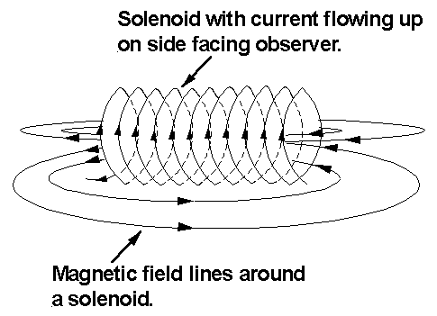 Fig.

Image Source: http://webs.mn.catholic.edu.au/physics/emery/prelim_electrical.htm

*Magnetic Field surrounding a Solenoid*

– present information using X and • to show the direction of a current and direction of a magnetic field

A × represents a current flowing down into the page. A **•** represents a current flowing out of the page. So using the right hand rule, you can determine the direction of the magnetic field around the wire.

Example Problem:

**Q.** Show the magnetic field around the wire. (Question in black, answer in grey.)

× ×

× ×

**Q.** Show the direction of the conventional current in the wire. (Question in black, answer in grey.)

X X X

X X X

**• • •**

**• • •**

**A.** X represents into the page, **•** represents out of the page, so when you line-up your right hand fingers in that way your thumb points to the left, so the conventional current is flowing that way.

8. identify data sources, gather, process and analyse information to explain one application of magnetic fields in household appliances

Electric motors are an application of magnetic fields and electromagnetism.

## 6. Safety devices are important in household circuits

1. discuss the dangers of an electric shock from both a 240 volt AC mains supply and various DC voltages, from appliances, on the muscles of the body

When muscles of the body are exposed to electric shock,

* **the muscles contract**
* **the heart muscle goes into fibrillation** (this is when the heart beats irregularly)
* electric shock can result in **death**

AC is much more dangerous than DC.

2. describe the functions of circuit breakers, fuses, earthing, double insulation and other safety devices in the home

Circuit breakers work by shutting off electricity when the current exceeds a safe level. Fuses do the same thing but work by allowing the fuse wire to melt when the current is too high. Circuit breakers are much more common in houses than fuses, as circuit breakers only need to be reset, whereas fuses need to be replaced. Earthing refers to allowing excess current to go to the ground instead of building up and causing potential problems. In a standard power point the bottom pin is used for earthing. Double insulation in coating the wire twice (with non-conductors), this means that if one fails the other coating will protect you.

# 8.4 MOVING ABOUT

## Contextual Outline:

Increased access to transport is a feature of today’s society. Most people access some form of transport for travel to and from school or work and for leisure outings at weekends or on holidays. When describing journeys that they may have taken in buses or trains, they usually do so in terms of time or their starting point and their destination. When describing trips they may have taken in planes or cars, they normally use the time it takes, distance covered or the speed of the vehicle as their reference points. While distance, time and speed are fundamental to the understanding of kinematics and dynamics, very few people consider a trip in terms of energy, force or the momentum associated with the vehicle, even at low or moderate speeds.

The faster a vehicle is travelling, the further it will go before it is able to stop when subject to a constant retarding force. Major damage can be done to other vehicles and to the human body in collisions, even at low speeds. This is because during a collision some or all of the vehicle’s kinetic energy is dissipated through the vehicle and the object with which it collides. Further, the materials from which vehicles are constructed do not deform or bend as easily as the human body. Technological advances and systematic study of vehicle crashes have increased understanding of the interactions involved, the potential resultant damage and possible ways of reducing the effects of collisions. There are many safety devices now installed in or on vehicles, including seat belts and air bags. Modern road design takes into account ways in which vehicles can be forced to reduce their speed.

This module increases students’ understanding of the nature and practice of physics and the implications of physics for society and the environment.

© Board of Studies NSW, Stage 6 Physics Syllabus.

## 1. Vehicles do not typically travel at a constant speed

1. identify that a typical journey involves speed changes

In a typical journey your speed changes throughout. Your journey usually begins with a speed of zero, so your speed must change in order to get anywhere.

2. distinguish between the instantaneous and average speed of vehicles and other bodies

Instantaneous speed is the speed that you are travelling at any given instant. Average speed is an average speed thought the whole journey. Average speed is given by the total distance you travelled divided by the time it took you.

3. distinguish between scalar and vector quantities in equations

Scalar quantities only specify a magnitude, with no direction. Examples include time, distance, speed and mass. For distance, 5meters, you do not say 5meters left, that would be displacement.

Vector quantities specify a magnitude and direction. Examples include displacement, velocity and force. For velocity, 5ms-1 north, specifies the magnitude 5 ms-1 and a direction, north.

4. compare instantaneous and average speed with instantaneous and average velocity

Instantaneous speed is a scalar quantity, on the other hand instantaneous velocity is a vector quantity.

Average speed is also a scalar quantity and average velocity is a vector quantity. Average speed takes into account your whole journey, where as average velocity only takes into account the starting and ending points.

5. define average velocity as:



Average velocity is change in displacement divided by change in time. Or,



1. plan, choose equipment or resources for, and perform a first-hand investigation to measure the average speed of an object or a vehicle

The average speed of a car can be calculated by measuring the total distance, and dividing it by the time it took.

2. solve problems and analyse information using the formula :



where r = displacement

3. present information graphically of:

– displacement vs time

– velocity vs time

for objects with uniform and nonuniform linear velocity

|  |  |
| --- | --- |
| A 5 10 15 20 25 30  time (s)  15  10  5  displacement (m)  D E  B C  F  *Displacement Time Graph*  A – B, constant speed = gradient.  B – C, at rest.  C – D, constant speed = gradient.  D – E, at rest.  E – F, returns to starting position, at constant speed. | A 5 10 15 20 25 30  time (s)  15  10  5  velocity (m/s)  *Velocity Time Graph*  This is a velocity time graph of displacement time graph to the left.  Gradient = Acceleration  Area under the curve = Displacement |

## 

## 2. An analysis of the external forces on vehicles helps to understand the effects of acceleration and deceleration

1. describe the motion of one body relative to another

The motion of a body is measured relative to another body. For example if you are walking forward at 1km/h, relative to the earth, you are moving 1km/h forward. However relative to you, you are still and the earth is moving backwards at 1km/h.

Another example is shown below. Two cars, A and B are travelling at 100km/h and 50km/h respectively. How fast is car A travelling relative to car B. Simply use your knowledge about addition and subtraction of vectors to do A – B (See Appendix A). You get relative to car B, car A is travelling at 50km/h. The same theory can be applied to multidimensional problems of the same nature.

Fig.

50km/h

100km/h

A

B

2. identify the usefulness of using vector diagrams to assist solving problems

As shown in Appendix A, vector diagrams are used to add vectors, to find the resultant vector. This can be used to find the net force on an object from many smaller forces. Addition of vectors is also used to find total displacement.

3. explain the need for a net external force to act in order to change the velocity of an object

According to Newtons 1st law of motion, a body will stay in a state of uniform motion unless acted on by an external force. So to change a body’s state of motion, you need an external force.

4. describe the actions that must be taken for a vehicle to change direction, speed up and slow down

As stated by Newtons 1st law of motion, in order to change a vehicles direction or speed, you need an external force, to act on the vehicle. However on earth there is, gravity, air resistance and friction to slow a car down, and trust from the engine and friction with the ground and the tyres to speed up a car.

5. describe the typical effects of external forces on bodies including:

– friction between surfaces

– air resistance

Most of real life situations are affected by air resistance, and friction. These forces oppose motion of a body.

6. define average acceleration as:



therefore



Average acceleration is given by, the above formula. Average acceleration only takes into account the starting and ending points.

7. define the terms ‘mass’ and ‘weight’ with reference to the effects of gravity

Your mass doesn’t change depending on the force of gravity. Mass is a measure of the amount of matter in a body. Your weight is a measure of the force you exert down on earth. Weight is equal to mass times force due to gravity, which on earth is 9.8ms-2. This is an extension of newtons 2nd law of motion. 

8. outline the forces involved in causing a change in the velocity of a vehicle when:

– coasting with no pressure on the accelerator

– pressing on the accelerator

– pressing on the brakes

– passing over an icy patch on the road

– climbing and descending hills

– following a curve in the road

In order for a vehicle to change velocity, a force must be applied to it. Many forces are constantly acting on a moving vehicle, however the forces that result in a change of velocity are listed below.

|  |  |
| --- | --- |
| **Situation** | **Forces acting on the vehicle.** |
| Coasting with no pressure on the accelerator | Air Resistance, Friction with ground. |
| Pressing on the accelerator | Engine pushing the car forward. |
| Pressing on the brakes | Friction with the brake pads. |
| Passing over an icy patch on the road | Not much friction, so little change in velocity. |
| Climbing and descending hills | Gravity is either opposing or assisting motion. |
| Following a curve in the road | Centripetal Force. |

9. interpret Newton’s Second Law of Motion and relate it to the equation:



Newtons second law of motion states, ‘Change of motion is proportional to the imprest force and takes place in the direction of the straight line in which that force is impressed’, in simple terms this means, that acceleration is proportional to the force, with the acceleration being in the same direction of the force. The key word is proportional, not equal, so it is the mass that makes in equal instead of just proportional. This leads to the equation, .

10. identify the net force in a wide variety of situations involving modes of transport and explain the consequences of the application of that net force in terms of Newton’s Second Law of Motion

Net force is the sum of all the forces acting on a body. In transportation the net forces is in the direction of where the vehicle is travelling. The net force, depends upon the mass and the acceleration of the vehicle, as stated by Newtons second law of motion. So if the acceleration is kept the same for all vehicles, heavy vehicles will exert a greater force than lighter ones.

1. analyse the effects of external forces operating on a vehicle

External forces acting on a vehicle include, air resistance, friction with the ground and gravity. Air resistance and friction oppose the motion of the car. However without friction the car would never move. Gravity can either oppose or assist motion depending on if you are travelling up hill or down hill.

2. gather first-hand information about different situations where acceleration is positive or negative

When you increase your velocity at a constant rate you have a positive acceleration. Similar if you decrease your velocity at a constant rate you have a negative acceleration.

3. plan, choose equipment or resources for and perform a first-hand investigation to demonstrate vector addition and subtraction

See Appendix A.

4. solve problems using vector diagrams to determine resultant velocity, acceleration and force

See Appendix A.

5. plan, choose equipment or resources and perform first-hand investigations to gather data and use available evidence to show the relationship between force, mass and acceleration using suitable apparatus

This can be examined by dropping a known mass and letting fall under the force of gravity. And measure the acceleration with a ticket timer, or similar device.

6. solve problems and analyse information using:  for a range of situations involving modes of transport

7. solve problems and analyse information involving  for vehicles travelling around curves

Example Problem:

Determine the centripetal force acting on a 1tonne car as it goes around a bend of radius 5m at a speed of 18km/h.

 acting toward the centre of the bend.

## 

## 3. Moving vehicles have kinetic energy and energy transformations are an important aspect in understanding motion

1. identify that a moving object possesses kinetic energy and that work done on that object can increase that energy

Anything that is moving has kinetic energy. The formula for kinetic energy is,



If work is applied to an object, the velocity increases, and so does the kinetic energy.

Work done is given by the formula,



2. describe the energy transformations that occur in collisions

There are two types of collisions, elastic and inelastic. Elastic collisions are when the two bodies collide then bounce off. Inelastic collisions are when the two bodies stick together to behave as one after the collision.

In elastic collisions the kinetic energy of each colliding body can change, but the total kinetic energy of the system does not change. Momentum is conserved.



In inelastic collisions the kinetic energy of the colliding system is not conserved. This loss of kinetic energy is changed into other forms of energy, suchas **sound energy**. Momentum is conserved. The formula for finding the velocity of the body after the collision is found with the following formula;

 OR 

In a collision:



Remembering that if the objects stick together after the collision,  and  become the same number . So rearranging the above equation you get. 

3. define the law of conservation of energy

‘In an isolated system, energy can be transferred from one type to another, but the total energy of the system remains constant.’

1. solve problems and analyse information to determine the kinetic energy of a vehicle and the work done using the formulae:

 and 

2. analyse information to trace the energy transfers and transformation in collisions leading to irreversible distortions

## 

## 4. Change of momentum relates to the forces acting on the vehicle or the driver

1. define momentum as: 

Momentum = Mass  Velocity

2. define impulse as the product of force and time

Impulse = Force  Time

3. explain why momentum is conserved in collisions in terms of Newton’s Third Law of motion

Newtons Third Law states that for every action there is an equal and opposite reaction. In a collision, there must be an equal and opposite force. So the momentum before must equal the momentum after.

1. solve problems and analyse secondary data using: ** and 

2. perform first-hand investigations to gather data and analyse the change in momentum during collisions

3. solve problems that apply the principle of conservation of momentum to qualitatively and quantitatively describe the collision of a moving vehicle with:

– a stationary vehicle

– an immoveable object

– another vehicle moving in the opposite direction

– another vehicle moving in the same direction

When a moving body collides with a stationary one, the stationary one speeds up and the moving one slows down. When a moving body collides with an immoveable object, the moving bodies’ velocity changes direction. When a moving body collides with another body moving in the opposite direction, they both change direction after collision. When a moving body collides with another body moving in the same direction, one speed’s up and the other slows down.

**Extension**: (This can be solved mathematically)

When a moving body (A) collides with a stationary body (B);

|  |  |
| --- | --- |
| Mass of A: 5kg  Mass of B: 10kg | Velocity of A: 0.5m/s  Velocity of B: 0m/s |





These two equations can be solved simultaneously to find the resulting velocities.

## 5. Safety devices are utilised to reduce the effects of changing momentum

1. define the inertia of a vehicle as its tendency to remain in uniform motion or at rest

Inertia is the tendency of a body to remain in uniform motion or at rest. This means that an object has a tendency to continue to do what it is doing. That is why when you crash a vehicle into a wall, it will continue to collide and squash into the wall instead of just stopping. This is also why a passenger in a vehicle continues to go forward when the breaks of a vehicle are applied. Because the car may have forces slowing it down but the passenger has a tendency to continue forward.

2. discuss reasons why Newton’s First Law of Motion is not apparent in many real world situations

Because there are many forces acting on a body on earth to oppose its motion, such as, air resistance, friction and gravity.

3. assess the reasons for the introduction of low speed zones in built-up areas and the addition of air bags and crumple zones to vehicles with respect to the concepts of impulse and momentum

Air Bags and Crumple Zones both increase the stopping distance of a vehicle. Relating back to Impulse = Force  Distance, If the distance is increased, the force is lower, this reduces the forces put on an the vehicle, and the occupants inside it.

Low Speed zones are in place because, the slower your velocity, the less momentum you have and the faster you can stop.

4. evaluate the effectiveness of some safety features of motor vehicles

|  |  |
| --- | --- |
| **Safety Feature** | **Effectiveness** |
| ABS braking | ABS brakes allow a vehicle to stop without skidding. |
| Air bags | Air bags work by increasing the stopping distance of the people inside the car thus decreasing the force imposed on them. |
| Crumple zones | Crumple zones increase the stopping distance of the car, thus decreasing the force imposed on the car. |
| Seat belts | Seat belts hold you in place inside the car. They stop you from being thrown around in the car. |
| Head restraint | This stops the passengers head being hyper extended. It prevents whiplash to some extent. |

1. gather and process first-hand data and/or secondary information to analyse the potential danger presented by loose objects in a vehicle

If the vehicle stops suddenly then they can move at high speeds inside the car.

2. identify data sources, gather, process, analyse, present secondary information and use the available evidence to assess benefits of technologies for avoiding or reducing the effect of a collision

Includes, Air Bags, Crumple Zones and Seat Belts.

# 8.5 THE COSMIC ENGINE

## Contextual Outline:

The Universe began with a singularity in space-time. After the initial explosion, the Universe started to expand, cool and condense, forming matter. As part of this ongoing process the Sun and the Solar System were formed over  years ago from a gas cloud which resulted from a supernova explosion. The condensing gas and dust that formed the Sun and the planets contained all its original elements. The planets were formed when matter came together under the influence of gravity.

This module increases students’ understanding of the history of physics, implications of physics for society and the environment and current issues, research and developments in physics.

© Board of Studies NSW, Stage 6 Physics Syllabus.

## 1. Our Sun is just one star in the galaxy and ours is just one galaxy in the Universe

1. outline the historical development of models of the Universe from the time of Aristotle to the time of Newton

**Aristotle’s** model of the Universe said that the earth was round. However his model was **geocentric**, meaning he thought that the Earth was the centre of the Universe. He also believed that the sun and the stars were in a celestial sphere that rotated around earth.

Fig.

earth

celestial sphere

sun

stars

moon

*Aristole’s Geocentric Model*

**Aristarchus’s** model was heliocentric, meaning that the sun was the centre of the Universe. Aristarchus also believed that the sun was much bigger than the earth and that the reason why everything appeared to rotate around the earth was because earth rotates on its axis once a day.

**Copernicus** also brought forward a heliocentric model.

**Brahe’s** model of the universe was part geocentric and part heliocentric. He had the planets and stars rotating around the sun. However he had the sun rotating around earth.

**Kepler** discovered 3 Laws:

1. Planets travel in elliptical orbits around the sun with the sun at one of the two foci.

Diagram looking from above, with the sun at one of the two foci.

1. The speed of the orbiting planet increases as its radius decreases, and the speed decreases as the radius increases.
2. The time a planet takes to orbit is dependent of the radius of the orbit.

T2 ∝ R3

T = period (time for 1 orbit)

R = radius of orbit

**Galilei** was the first person to look at the stars and planets with a telescope. He made many observations of planets, stars and moons.

**Newton** deduced the Law of Universal Gravitation. Gravity is a force that pulls masses together. Every mass in the Universe exerts a force of gravity on every other mass. The force of gravity between two bodies is determined by their masses and the distance between them.



G = 6.67 × 10–11 N m2 kg–2

2. identify data sources, and gather, process and analyse information to assess one of the models of the Universe developed from the time of Aristotle to the time of Newton to identify limitations placed on the development of the model by the technology available at the time

The early models were limited by the technology that was available at the time. For example, since the development of the telescope, more information about the universe has been collected.

## 2. The first minutes of the Universe released energy which changed to matter, forming stars and galaxies

1. outline the discovery of the expansion of the Universe by Hubble, following its earlier prediction by Friedmann

Friedmann proved mathematically that the universe is expanding. However he made some assumptions in order to prove it. Hubble showed that the universe was expanding, by showing that almost all the galaxies are red-shifted, meaning that they are moving away from us.

2. describe the transformation of radiation into matter which followed the ‘Big Bang’

The universe started with a ‘Big Bang’. At the beginning of the big bang, there was only radiation. However over time ranging from 300 seconds to 1 million years, the particles combined to form atoms (matter).

3. identify that Einstein described the equivalence of energy and mass

Einstein discovered that; E = mc2. This relates energy and mass. It also means that energy can be converted to mass, and mass can be converted to energy.

4. outline how the accretion of galaxies and stars occurred through:

Accretion is the process of the growth of a body by gathering more matter.

a) expansion and cooling of the Universe

As the universe expanded, it cooled (because the energy has to be distributed over a larger volume). The Steady State theory says that as the universe is expanding, more matter is created to keep its density constant, however, this theory is not supported.

b) subsequent loss of particle kinetic energy

The temperature of a body is related to the kinetic energy in it particles. So as the particle kinetic energy got lower the temperature decreased. This resulted in the amount of matter in the universe exceeding the amount of radiation.

c) gravitational attraction between particles

The Law of Gravitation states that every mass in the universe is attracted by gravity to every other mass in the universe. So stars slowly attracted other stars, which over time resulted in masses of stars clumped together, known as galaxies.

d) lumpiness of the gas cloud that then allows gravitational collapse

Lumpiness of gas cloud is where some parts are denser than others.

5. identify data sources and gather secondary information to describe the probable origins of the Universe

According to the ‘Big Bang’ theory, the universe began as a singularity in space-time, which rapidly expanded in a huge explosion know as the big bang.

The 2 main pieces of evidence for the big bang are:

* Red shift of Galaxies
* Background Microwave Radiation

## 3. Stars have a limited life span and may explode to form supernovas

1. define the relationship between the temperature of a body and the dominant wavelength of the radiation emitted from that body

As the temperature of a body increases the peak wavelength decreases. This is shown in the graph below.

Fig.

Wavelength (nm)

Intensity

8000 K

6000 K

3000 K

*Intensity vs. Wavelength*

2. identify that the surface temperature of a star is related to its colour

The colour of a star depends on its surface temperature. The comparison of colour and surface temperature can be examined on the Hertzsprung-Russell diagram.

3. describe a Hertzsprung-Russell diagram as the graph of a star’s luminosity against its colour or surface temperature

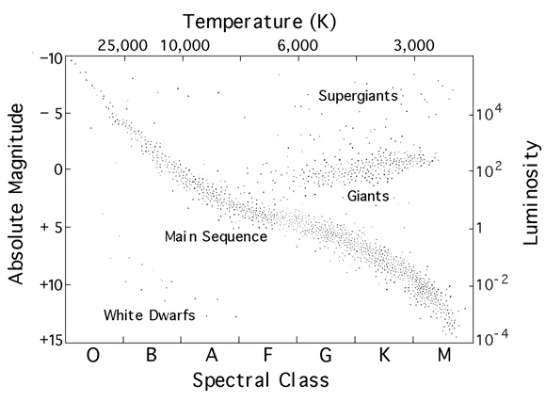

Fig.

*Hertzsprung-Russell diagram. (Diagram Source unknown)*

The Hertzsprung-Russell diagram plots a stars surface temperature against its luminosity. Each dot is a star. The stars can be classed into groups depending on their position on the H-R diagram. A stars life cycle can also be drawn on the H-R diagram.

4. identify energy sources characteristic of each star group, including Main Sequence, red giants, and white dwarfs

Our sun is part of the main sequence. Referring to the H-R diagram you can see that Dwarfs have the lowest luminosity, then giants, then supergiants with the highest luminosity.

Orange/Red stars are the coldest stars, then white stars, then blue stars being the hottest stars.

|  |  |
| --- | --- |
| **HR Group** | **Energy Sources** |
| Main Sequence | Nuclear Fusion of Hydrogen to Helium in core. |
| Red Giants | Nuclear Fusion of Helium to Carbon in core, with Hydrogen fusion continuing in shell. |
| White Dwarfs | No nuclear fusion |

5. gather secondary information to relate brightness of an object to its luminosity and distance

The brightness of a star depends on the stars luminosity and its distance from the viewer.

6. solve problems to apply the inverse square law of intensity of light to relate the brightness of a star to its luminosity and distance from the observer

The brightness of a star is given by:



7. process and analyse information using the Hertzsprung-Russell diagram to examine the variety of star groups, including Main Sequence, red giants, and white dwarfs

## 4. The Sun is a typical star, emitting electromagnetic radiation and particles that influence the Earth

1. identify that energy may be released from the nuclei of atoms

Radiation is the energy that is released from the nuclei of atoms.

2. describe the nature of emissions from the nuclei of atoms as radiation of alpha α and beta β particles and gamma γ rays in terms of:

a) ionising power

b) penetrating power

c) effect of magnetic field

d) effect of electric field

|  |  |  |  |
| --- | --- | --- | --- |
|  | **alpha α rays** | **beta β rays** | **gamma γ rays** |
| Nature of Radiation | Helium Nucleus (He2+) | Electron (e–) | Electromagnetic Radiation |
| Ionising Power  (The ability to remove electrons from atoms to form ions) | High | Low | Very Low |
| Penetrating Power | Very Low | Low | Very High |
| Effect of Magnetic Field | Deflected with large radius.  (Up, when magnetic field is into page) | Deflected with small radius.  (Down, when magnetic field is into page) | No effect |
| Effect of Electric Field | Attracted to – | Attracted to + | No effect |

3. identify the nature of emissions reaching the Earth from the Sun

Emissions from the sun include:

* **Electromagnetic radiation** – however most of it is not allowed through our atmosphere.
* **Charged Particles** – Protons and electrons, this is known as solar wind.
* **Neutrinos** – very small neutral particles.

4. describe the particulate nature of the solar wind

Solar wind consists or Ionised/Charged particles.

5. outline the cyclic nature of sunspot activity and its impact on Earth through solar winds

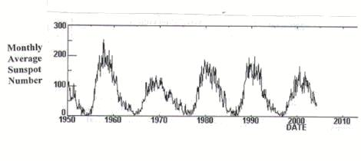

Fig.

*Sunspot Activity* (<http://science.nasa.gov/ssl/pad/solar/sunspots.htm>)

Sunspot Activity follows an 11 year cycle. They release large amounts of electromagnetic radiation, which affects the earth in way such as:

* Disruption of radio/telephone communication.
* Overloading electrical power lines, which causes blackouts
* Affects earth’s magnetic field.
* Causes aural displays.

6. describe sunspots as representing regions of strong magnetic activity and lower temperature

A sunspot is an area on the sun that has **strong magnetic activity** and a **lower temperature**. They appear as dark regions, with an irregular shape.

7. perform a first-hand investigation to gather information to compare the penetrating power of alpha, beta and gamma radiation in a range of materials

8. identify data sources, gather and process information and use available evidence to assess the effects of sunspot activity on the Earth’s power grid and satellite communications

The effects of high levels of sunspot activity can be seen on earth through the disruption of satellite communications and power grids.

# APPENDIX A

Here is a comprehensive guide to adding vectors. For the physics syllabus I would suggest you are aware of graphical methods, and analytical methods.

Vectors can be added using graphical methods, analytical methods or geometric methods.

The **graphical** solution involves drawing the forces to scale, head to tail, (aka. force diagram) and then the resultant is the force that is from the starting point to the end point.

A

B

C

A+B+C

*Graphical Solution of Vector Addition*

The **geometric** solution involves taking the force diagram and solving angles and side lengths using geometry and trigonometry. The Sine rule and Cosine Rule are useful here.

|  |  |
| --- | --- |
| A  b c  C B  a  In a triangle with sides a, b, c and their corresponding angles A, B, C respectively, the sine and cosine rule state: | |
| Sine Rule: | Cosine Rule: |

The **analytical** solution involves splitting each vector into a horizontal and vertical component. These two components will sum together to equal the original vector so therefore they will have the same effect as the original vector. Once you have the horizontal and vertical components you can sum the horizontals and the verticals individually and then combine them together at the end to get a resultant force.

To split a vector into horizontal and vertical components the following formulae are used;



To convert these x and y components back into one force use these formulae;



7.94°

10kN

30°

A

15°

50kN

Example Problem:

Determine the resultant force acting on point A.



So the resultant force acting on A is 57.51kN

# 

# REFERENCES/ RESOURCES

Stage 6 Physics Syllabus 2002, © Board of Studies

**Excel Preliminary Physics**

Copyright © 2000 Neville Warren

ISBN 1 74020 085 3

Pascal Press

**Physics 1**

ISBN 0 7016 3781 1

John Wiley & Sons Australia, Ltd

**Surfing - Science Press**

Physics: The World Communicates

Physics: Electrical Energy in the Home

Physics: Moving About

Physics: The Cosmic Engine

**Web Resources**

http://www.caresa.com.au

Notes & Practice Questions

http://www.webs.mn.catholic.edu.au/physics/emery/

Notes & really good past papers

<http://www.boredofstudies.org/wiki/>

Notes & Past papers

http://intrepix.tripod.com/en/notes/physics.html

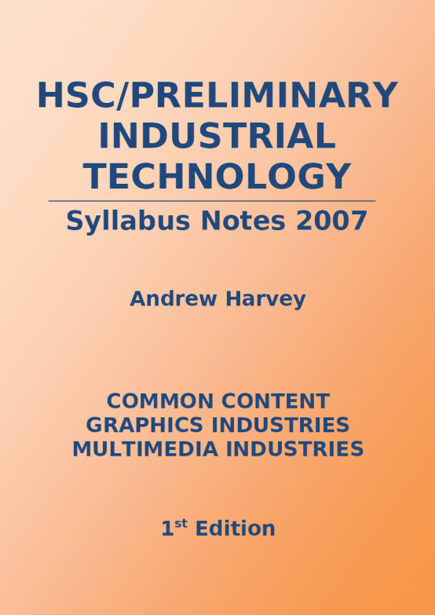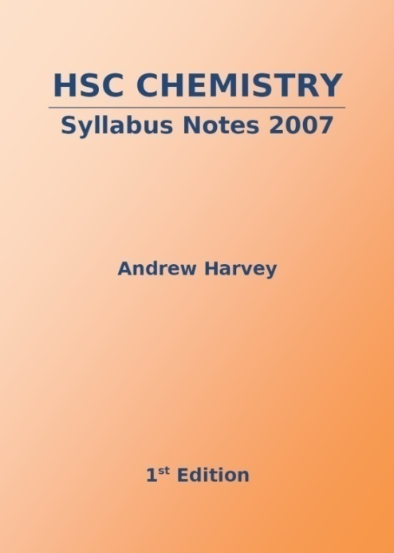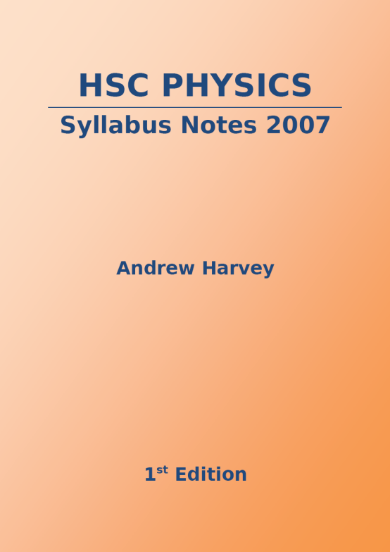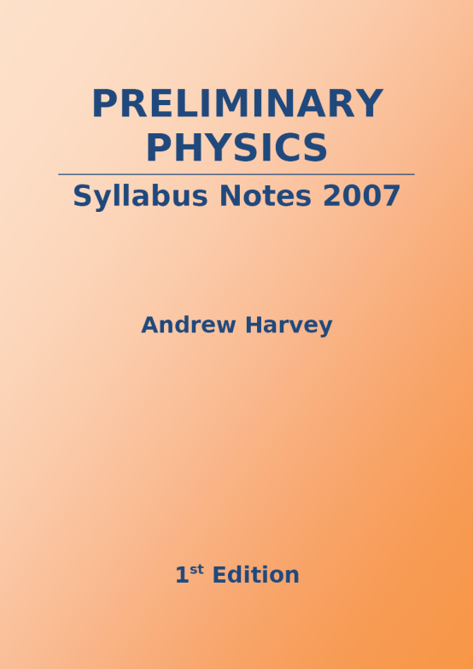

**andrew.harvey4.googlepages.com**

**plus many more…**

**Other titles by Andrew Harvey…**